

Software Requirements Specification

**Version1.1**

**Quốc Nhân**

**15/11/2019**

**VERSION HISTORY**

|  |  |  |  |  |  |
| --- | --- | --- | --- | --- | --- |
| **Version #** | **Implemented**  **By** | **Revision**  **Date** | **Approved**  **By** | **Approval**  **Date** | **Reason** |
| 1.0 | Anh Minh | 12/11/2019 |  |  | Create Document SRS version 1.0 |
| 1.1 | Quốc Nhân | 15/11/2019 |  |  | Update v1.1 |
|  |  |  |  |  |  |
|  |  |  |  |  |  |

Nội dung

**I. USE CASE DIAGRAM 2**

1. Use Case Diagram General 2

2. Use Case Diagram Leader 3

3. Use Case Diagram Department Head 4

4. Use Case Diagram Admin 4

5. Use Case Diagram Employees 4

**II. ENTITY TITLE 4**

**III. USE CASE LIST 4**

**IV. USE CASE DESCRIPTION 5**

**Account management 5**

1. Login 5

2. Logout 6

3. Search personnel list 7

4. View personnel list 7

5. Upload organizational chart 8

6. View organizational chart 9

7. Add business trip fees regulations 10

8. View business trip fees regulations 10

9. Add normal salary regime 11

10. View normal salary regime 12

11. Add holiday schedule 12

12. View holiday schedule 13

13. Add personnel appointment 13

14. View personnel appointment 14

15. Add team building activity 15

16. View team building activity 15

17. View account information 16

18. Add account 17

19. Hide account 17

20. Edit account 18

21. Decentralization 18

**Real estate project management 5**

22. View real estate listings 19

23. Search real estate listings 19

24. Add real estate listings 19

25. Edit real estate listings 19

**Statistical management, reporting 5**

26. View business results week 19

27. Upload business results week 19

28. Search business results week 19

29. View table comparing business results 19

30. View graph of business results 19

**Business trip manager 5**

31. Sign up for business trip 19

32. Browse business trip 19

33. Cancel business trip 19

34. Locate business trip 19

35. View business trip history 19

36. Search business trip history 19

**Management quit 5**

37. Register to quit your job 20

38. History of leave 21

39. Approval of leave 20

40. Search of leave 19

**Other functions 5**

41. Happy Birthday 22

1. **USE CASE DIAGRAM**
2. **Use Case Diagram General**

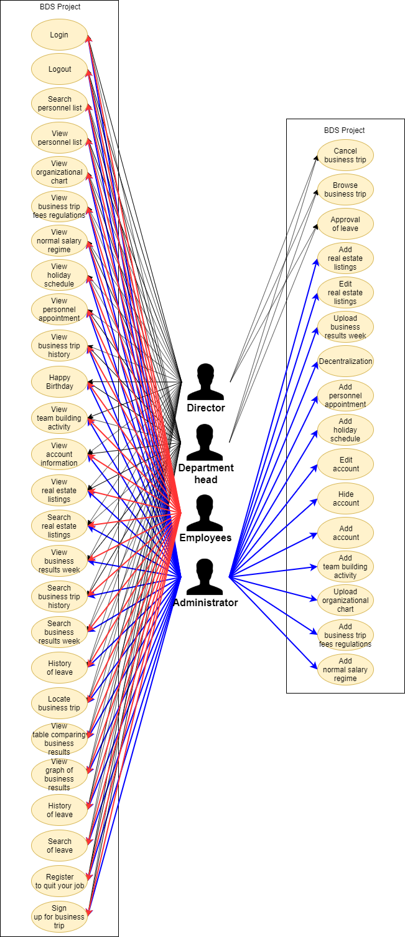

1. **Use Case Diagram Director**

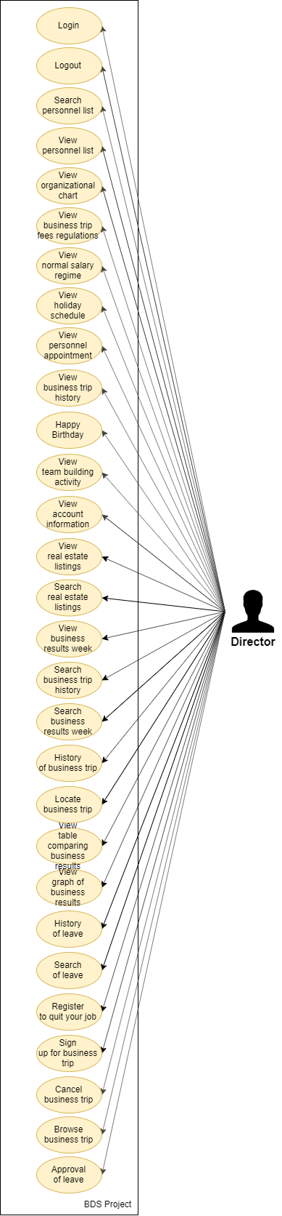

1. **Use Case Diagram Department Head**

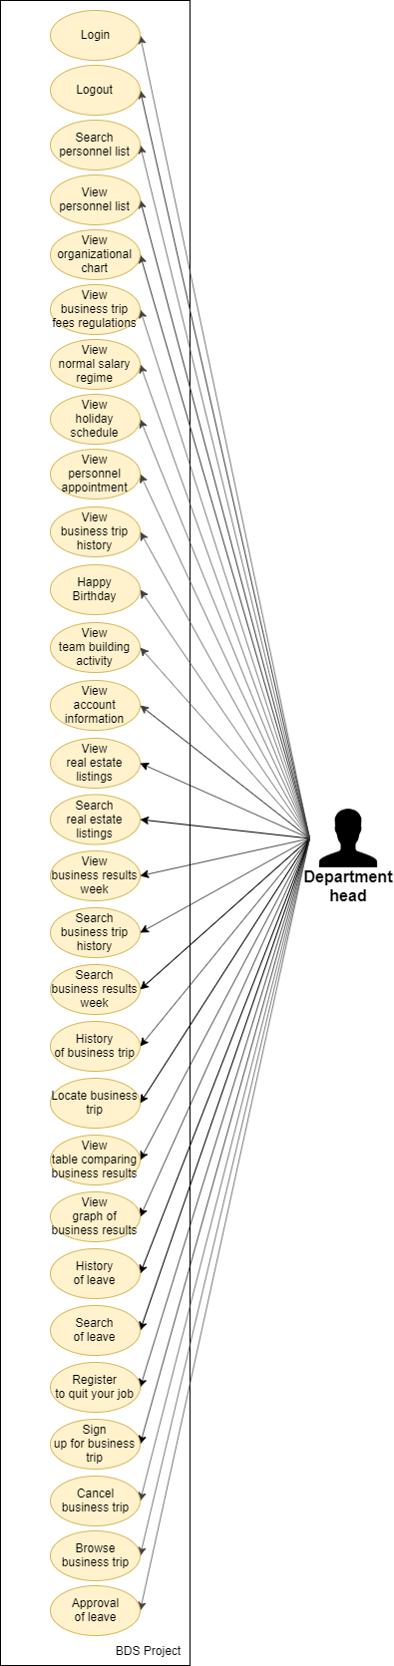

1. **Use Case Diagram Admin**

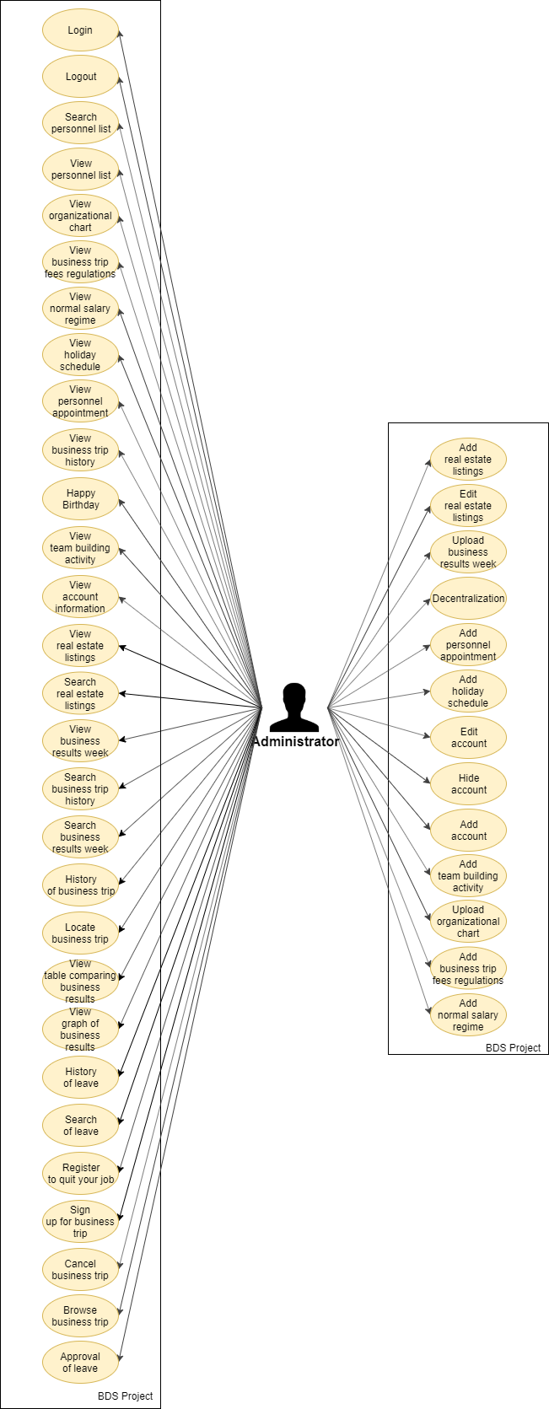

1. **Use Case Diagram Employees**

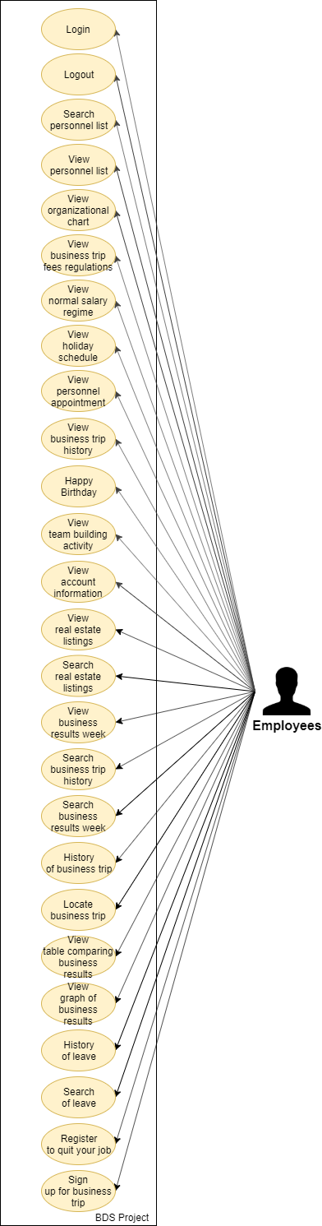

1. **ENTITY TITLE**

|  |  |
| --- | --- |
| **Entity ID** | **Entity Title** |
| E01 | Director |
| E02 | Department Heads |
| E03 | Administrator |
| E04 | Employees |

1. **USE CASE LIST**

List all use cases following this template:

|  |  |  |  |  |
| --- | --- | --- | --- | --- |
| **#** | **UC ID** | **UC Name** | **Description** | **Actors** |
| 01 | FR.01 | Login |  |  |
| 02 | FR.02 | Logout |  |  |
| 03 | FR.03 | View account information |  |  |
| 04 | FR.04 | Search personnel list |  |  |
| 05 | FR.05 | View personnel list |  |  |
| 06 | FR.06 | Upload organizational chart |  |  |
| 07 | FR.07 | View organizational chart |  |  |
| 08 | FR.08 | Add business trip fees regulations |  |  |
| 09 | FR.09 | View business trip fees regulations |  |  |
| 10 | FR.10 | Add normal salary regime |  |  |
| 11 | FR.11 | View normal salary regime |  |  |
| 12 | FR.12 | Add holiday schedule |  |  |
| 13 | FR.13 | View holiday schedule |  |  |
| 14 | FR.14 | Add personnel appointment |  |  |
| 15 | FR.15 | View personnel appointment |  |  |
| 16 | FR.16 | Add team building activity |  |  |
| 17 | FR.17 | View team building activity |  |  |
| 18 | FR.18 | Add account |  |  |
| 19 | FR.19 | Hide account |  |  |
| 20 | FR.20 | Edit account |  |  |
| 21 | FR.21 | Decentralization |  |  |
| 22 | FR.22 | View real estate listings |  |  |
| 23 | FR.23 | Search real estate listings |  |  |
| 24 | FR.24 | Add real estate listings |  |  |
| 25 | FR.25 | Edit real estate listings |  |  |
| 26 | FR.26 | View business results week |  |  |
| 27 | FR.27 | Upload business results week |  |  |
| 28 | FR.28 | Search business results week |  |  |
| 29 | FR.29 | View table comparing business results |  |  |
| 30 | FR.30 | View graph of business results |  |  |
| 31 | FR.26 | View business results week |  |  |
| 32 | FR.31 | Sign up for business trip |  |  |
| 33 | FR.32 | Browse business trip |  |  |
| 34 | FR.33 | Cancel business trip |  |  |
| 35 | FR.34 | Locate business trip |  |  |
| 36 | FR.35 | View business trip history |  |  |
| 37 | FR.36 | Search business trip history |  |  |
| 38 | FR.37 | Register to quit your job |  |  |
| 39 | FR.38 | History of leave |  |  |
| 40 | FR.39 | Approval of leave |  |  |
| 41 | FR.40 | Search of leave |  |  |
| 42 | FR.41 | Happy Birthday |  |  |

1. **USE CASE DESCRIPTION**

**Account management**

1. **Login**

|  |  |  |  |
| --- | --- | --- | --- |
| **Use Case ID:** | UC01 | | |
| **Use Case: Name:** | Login | | |
| **Created By:** |  | Created By: |  |
| **Date Created:** |  | Date Created: | 12/11/2019 |
| **Actors:** |  | | |
| **Description:** |  | | |
| **Trigger:** |  | | |
| **Pre-conditions:** |  | | |
| **Post-conditions:** |  | | |
| **Normal Flow:** |  | | |
| **Alternative Flows:** |  | | |
| **Exceptions:** |  | | |
| **Business Rules** |  | | |

1. **Logout**

|  |  |  |  |
| --- | --- | --- | --- |
| **Use Case ID:** | UC01 | | |
| **Use Case: Name:** | Login | | |
| **Created By:** |  | Created By: |  |
| **Date Created:** |  | Date Created: | 12/11/2019 |
| **Actors:** |  | | |
| **Description:** |  | | |
| **Trigger:** |  | | |
| **Pre-conditions:** |  | | |
| **Post-conditions:** |  | | |
| **Normal Flow:** |  | | |
| **Alternative Flows:** |  | | |
| **Exceptions:** |  | | |
| **Business Rules** |  | | |

**3. Search personnel list**

**4. View personnel list**

**5. Upload organizational chart**

**6. View organizational chart**

**7. Add business trip fees regulations**

**8. View business trip fees regulations**

**9. Add normal salary regime**

**10. View normal salary regime**

**11. Add holiday schedule**

**12. View holiday schedule**

**13. Add personnel appointment**

**14. View personnel appointment**

**15. Add team building activity**

**16. View team building activity**

**17. View account information**

**18. Add account**

**19. Hide account**

**20. Edit account**

**21. Decentralization**

**Real estate project management**

**22. View real estate listings**

**23. Search real estate listings**

**24. Add real estate listings**

**25. Edit real estate listings**

**Statistical management, reporting**

**26. View business results week**

**27. Upload business results week**

**28. Search business results week**

**29. View table comparing business results**

**30. View graph of business results**

**Business trip manager**

**31. Sign up for business trip**

**32. Browse business trip**

**33. Cancel business trip**

**34. Locate business trip**

**35. View business trip history**

**36. Search business trip history**

**Management quit**

**37. Register to quit your job**

**38. History of leave**

**39. Approval of leave**

**40. Search of leave**

**Other functions**

**41. Happy Birthday**